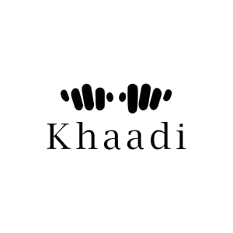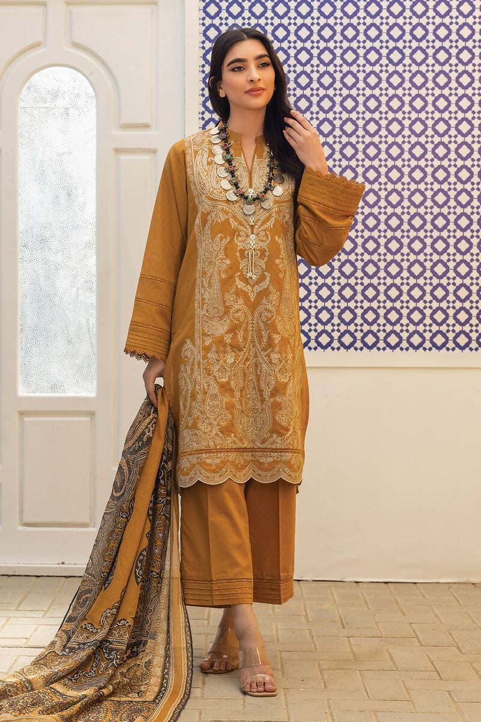

* **Details**
  + **Top Fabric:** Dyed Dobby | 3.25m
  + **Bottom Fabric:** Dyed Dobby | 2.5m
  + **Dupatta Fabric:** Digital Printed Cotton Square | 2.5m
  + **Campaign:** The Print Story

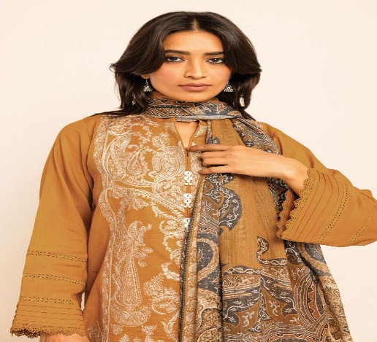This Pakistani women's wear in mustard fabric khaddar is versatile and can be styled in various ways. It can be paired with contrasting accessories and footwear to create a bold and fashionable look. Whether you're attending a formal event, a festive celebration, or simply want to make a fashion statement, this outfit is sure to turn heads and make you feel confident.